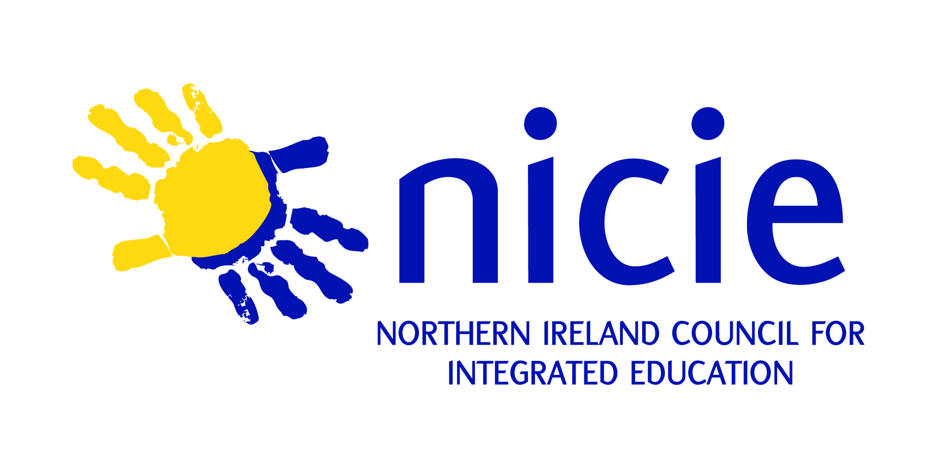

NICIE
Strategic Plan
2013 – 2016

Integrated education — a definition
Integrated education can be defined as educating together in schools pupils drawn in approximately equal numbers from the two major traditions in Northern Ireland with the aim of providing for them an excellent education that gives equal recognition to and promotes equal expression of both major traditions, while including and respecting those from other religions or of no religious belief.
Integrated education is committed to cultivating the individual’s self-respect and therefore respect for other people and other cultures. Integrated education means bringing children up to live as adults in a pluralist society, recognising what they hold in common, as well as what separates them, and accepting both.
The integrated school is essentially Christian in character; democratic and open in procedures and promotes the worth and self-esteem of all individuals within the school community.
Integrated education is underpinned by the agreed principles of equality, social responsibility, faith and values and parental involvement.

NICIE’s vision
NICIE’s vision for 2013–2016 is of ensuring there is integrated choice in every area, educating all children together, offering educational excellence and best practice in integration, and laying the foundation for a future in which an integrated education is the norm for all children in Northern Ireland.
NICIE’s mission
The mission of NICIE is to lead, promote and facilitate the development and growth of integrated education through a range of approaches, including innovation, influence, and working with others.

NICIE Strategic Aims
Strategic Aim 1: Growth To increase the numbers of children and young people experiencing an integrated education.
Strategic Objectives
- to work, through the area based planning process, to increase provision of integrated education;
- to support the consolidation and expansion of existing integrated schools;
- to ensure parental choice is respected and sufficient provision is available to meet parental demand;
- to work towards one third integrated provision in the overall system, ensuring an integrated choice in every area;
- to develop, test and sustain innovative approaches to supporting schools in becoming integrated, including through ‘transformation’;
- to work towards ensuring that all pre-school provision is genuinely non sectoral.

Strategic Aim 2: Excellence in integrated education To support the delivery of quality integrated education which delivers excellent experiences and outcomes.
Strategic Objectives
- to undertake and carry out the role of sectoral support body on implementation of ESA;
- to support existing integrated schools to achieve Excellence in Integrated Education Award (EIEA);
- to promote excellence in education and school improvement through the integrated ethos;
- to promote NICIE leadership development and capacity building across the integrated movement and to develop strategic partnerships to achieve this;
- to support curriculum development within the integrated ethos and produce relevant resources and guidance;
- to develop strategic relationships with the other sectors and key funders in order to enable NICIE to extend its work in promoting and developing ‘integration in practice’ and innovative approaches to integrating and sharing.

Strategic Aim 3: Inform, influence and promote To raise awareness, influence others and increase support for integrated education.
Strategic Objectives
  - to raise awareness (internally within the sector, and more widely), influence others, and increase support for integrated education;
  - to develop strategic relationships and to work with DE and other educational stakeholders to ensure that the case for integrated education is central to the development of educational policy;
  - to undertake, engage in and respond to policy consultation, and influence the development of new policies;
  - to use research to increase validity of integrated education (quantitative and qualitative) — market research and academic research;
  - to develop strategic relationships with IEF and other key stakeholders which ensures the case for integrated education is kept in the public eye;
  - to promote integrated education as a model for inclusive education, developing equality, diversity, respect and reconciliation through educational excellence — locally, nationally and internationally.

Strategic Aim 4: Internal capacity building To strengthen the organisation so that it achieves its mission successfully.
Strategic objectives
- to ensure the cost effective and efficient use of resources and staff to meet strategic objectives;
- to adopt a proactive approach to fundraising to develop and extend the work of NICIE;
- to strengthen NICIE’s capacity to carry out its work through a programme of continuous professional development;
- to ensure effective governance through enhanced structures and procedures;
- to improve mechanisms for internal communication;
- to maintain internal processes for monitoring, evaluation and reporting on the implementation of this strategic plan.

